Practice Problems Hints:

Sub queries and MERGE statement

**Practice Problem 1:** To complete problem 1, write an SQL query that uses a single row sub query in a WHERE clause.

**Helpful Hints:**

|  |  |
| --- | --- |
| **Key Words to Use:** | SELECT, FROM, WHERE |
| **Tables to Use:** | Books |
| **Columns to Select:** | Title, retail |
| **Conditions to Specify:** | Use a sub query in the WHERE clause |
| **Suggestions:** | - |

**Expected Output:**

**Note:** Records in the output might be in a different order.

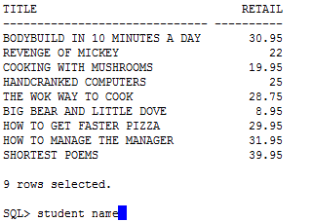

**Practice Problem 2:** To complete problem 2, write an SQL query that uses a multiple column subquery in a FROM clause. The subquery will use the group by statement.

**Helpful Hints:**

|  |  |
| --- | --- |
| **Key Words to Use:** | SELECT, FROM, WHERE |
| **Tables to Use:** | Books |
| **Columns to Select:** | title, category, cost |
| **Conditions to Specify:** | Use a multiple column sub query in the FROM clause |
| **Suggestions:** | - |

**Expected Output:**

**Note:** Records in the output might be in a different order.

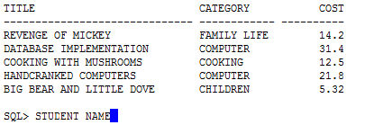

**Practice Problem 3:** To complete problem 3, write an SQL query that uses a single row sub query in a WHERE clause.

**Helpful Hints:**

|  |  |
| --- | --- |
| **Key Words to Use:** | SELECT, FROM, WHERE |
| **Tables to Use:** | Orders |
| **Columns to Select:** | order# |
| **Conditions to Specify:** | Use a single row sub query in the WHERE clause |
| **Suggestions:** | - |

**Expected Output:**

**Note:** Records in the output might be in a different order.

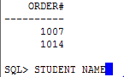

**Practice Problem 4:** To complete problem 4, write an SQL query that joins two tables and uses a multi row sub query in a HAVING clause. The sub query will join two tables.

**Helpful Hints:**

|  |  |
| --- | --- |
| **Key Words to Use:** | SELECT, FROM, WHERE, GROUP BY, HAVING |
| **Tables to Use:** | Orderitems, books, |
| **Columns to Select:** | Order#, quantity, paideach, isbn |
| **Conditions to Specify:** | Use a multi row sub query in the HAVING clause. Join 2 tables in the sub query. |
| **Suggestions:** | - |

**Expected Output:**

**Note:** Records in the output might be in a different order.

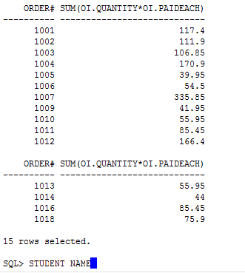

**Practice Problem 5:** To complete problem 5, write an SQL query that uses a multiple row subquery in a WHERE clause. The subquery will include the GROUP BY statement and another multiple row subquery in a HAVING clause.

**Helpful Hints:**

|  |  |
| --- | --- |
| **Key Words to Use:** | SELECT, FROM, WHERE, GROUP BY, HAVING |
| **Tables to Use:** | Bookauthor, orderitems |
| **Columns to Select:** | Lname, fname, isbn, quantity |
| **Conditions to Specify:** | Use a multi row sub query in the WHERE clause and HAVING clause |
| **Suggestions:** | - |

**Expected Output:**

**Note:** Records in the output might be in a different order.

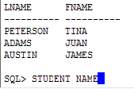

**Practice Problem 6:** To complete problem 6, write an SQL query that uses two multiple row subqueries in a WHERE clause joined with the AND operator. Each subquery will join multiple tables.

**Helpful Hints:**

|  |  |
| --- | --- |
| **Key Words to Use:** | SELECT, FROM, WHERE |
| **Tables to Use:** | Books, orderitems, orders |
| **Columns to Select:** | Title, category, order# |
| **Conditions to Specify:** | Use two multi row sub queries joined with an AND operator in the WHERE clause. |
| **Suggestions:** | - |

**Expected Output:**

**Note:** Records in the output might be in a different order.

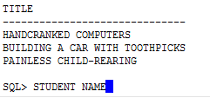

**Practice Problem 7:** To complete problem 7, write an SQL query that uses a single row subquery in a WHERE clause.

**Helpful Hints:**

|  |  |
| --- | --- |
| **Key Words to Use:** | SELECT, FROM, WHERE |
| **Tables to Use:** | Orders |
| **Columns to Select:** | Shipcity, shipstate, shipdate, orderdate |
| **Conditions to Specify:** | Use a single row sub query in the WHERE clause |
| **Suggestions:** | - |

**Expected Output:**

**Note:** Records in the output might be in a different order.

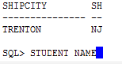

**Practice Problem 8:** To complete problem 8, write an SQL query that joins four tables and uses a single row subquery in a WHERE clause.

**Helpful Hints:**

|  |  |
| --- | --- |
| **Key Words to Use:** | SELECT, FROM, WHERE, JOIN, USING |
| **Tables to Use:** | Customers, orders, orderitems, books |
| **Columns to Select:** | Customer#, retail |
| **Conditions to Specify:** | Use a single row sub query in the WHERE clause |
| **Suggestions:** | - |

**Expected Output:**

**Note:** Records in the output might be in a different order.

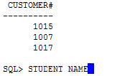

**Practice Problem 9:** To complete problem 9, write an SQL query that joins two tables and uses a multiple row sub query in a WHERE clause. The subquery will join three tables.

**Helpful Hints:**

|  |  |
| --- | --- |
| **Key Words to Use:** | SELECT, FROM, WHERE, JOIN, USING |
| **Tables to Use:** | Orders, orderitems, bookauthor, author |
| **Columns to Select:** | Customer#, isbn |
| **Conditions to Specify:** | Join 2 tables and use a multiple row sub query in the WHERE clause. Join 3 tables in the sub query |
| **Suggestions:** | - |

**Expected Output:**

**Note:** Records in the output might be in a different order.

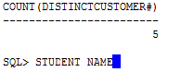

**Problem 10:** To complete problem 10, write an SQL query that uses a single row sub query in a WHERE clause.

**Helpful Hints:**

|  |  |
| --- | --- |
| **Key Words to Use:** | SELECT, FROM, WHERE |
| **Tables to Use:** | Books |
| **Columns to Select:** | Title, pubid |
| **Conditions to Specify:** | Use a single row sub query in the WHERE clause. |
| **Suggestions:** | - |

**Expected Output:**

**Note:** Records in the output might be in a different order.

